Fund of Database Systems
Spring 2024
Dr. Fatima Hamza
B55
Tamara Alasmar – 202103791
Saeeda Al-Marri – 202106704
Iman Khabaz – 202206112

Report Database project
From the description, we found the following:
Entities :
- Tour_trip -Tour_guide -Tour_package
-Reservation -Agent -QTA_website
-Customer -Transaction -Schedule.

Attributes:
-Tour_trip
Start_time | Duration | Destination | Price | Date | Trip_no | Location
Location is a composite attribute that have (Site and Landmarks).
-Tour_guide
Name | Number | Language (multivalued)

-Tour_package
Transportation | Package_no | Residence (multivalued) | Price | Type

-Reservation
Reserve_status | Reserve_no

-Agent
Name | Id | Account
Account is a composite attribute that have (Username and Password).
-QTA_website
Content | Link

-Customer
Contact_inf | Name | Age | Customer_id | Sex
Customer is a composite attribute that have (work_no , mobile_no and home_no).
-Transaction
Transc_no | Type | Date | Time

-Schedule
Stop_points | Working_time | Working_date

Relationships:
- Tour_trip and Tour_guide (1-1) relationship name is Work_for.
- Tour_trip and Tour_package (M-1) relationship name is Belongs.
- Tour_package and Reservaion (1-N) relationship name is Book.
- Tour_trip and Reservation (M-N) relationship name is Done_T_R.
- Reservation and Agent (M-N) relationship name is Make.
- Agent and QTA_website (M-1) relationship name is Login.
- QTA_website and Customer (1-M) relationship name is View.
- Agent and Customer (1-N) relationship name is Handle.
- Agent and Transaction (N-1) relationship name is Done_T_A.
- Tour_guide and Schedule (N-1) relationship name is Assigend.
Cardinalities:
- Tour_trip (1, N) and Tour_guide (1, 1).
- Tour_trip (1, 1) and Tour_package (1, N).
- Tour_package (1, M) and Reservaion (1, 1).
- Tour_trip (1, N) and Reservation (0, M).
- Reservation (0, N) and Agent (1, N).
- Agent (1, 1) and QTA_website (1, N).
- QTA_website (1, N) and Customer (1, 1).
- Agent (0, N) and Customer (1, 1).
- Agent (1, N) and Transaction (1, 1).
- Tour_guide (1, 1) and Schedule (1, N).

ER Diagram:
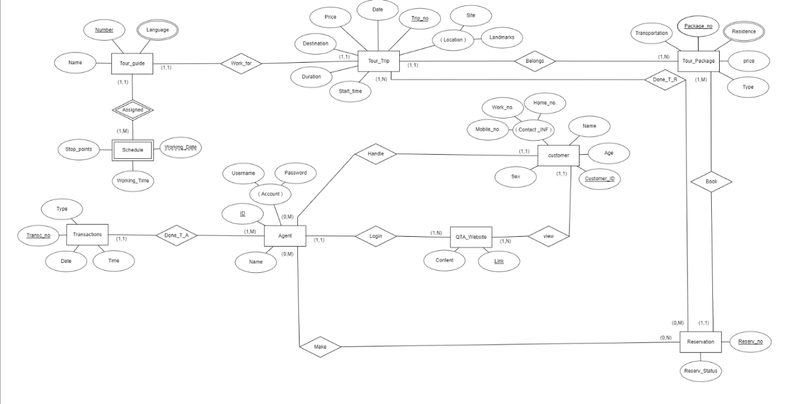
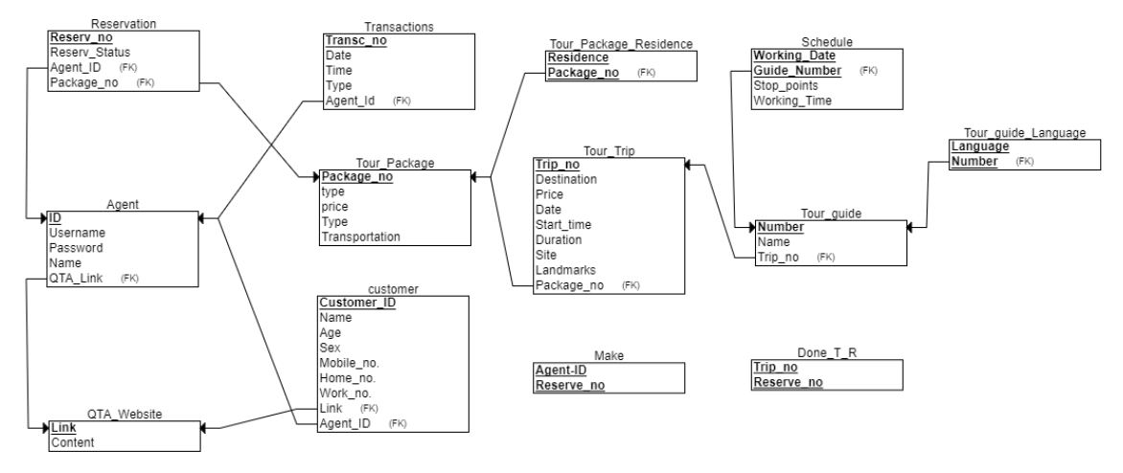
Relational Schema:

After we finish identifying the entities, attributes and relationships, we create for each entity a table with their attributes and creating table for the entities that have many to many relationships, and who are multivalued.
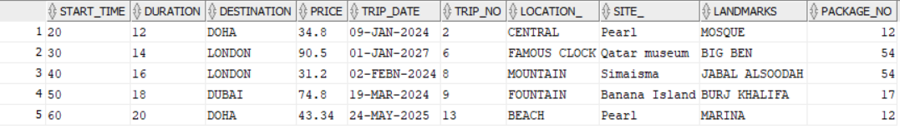
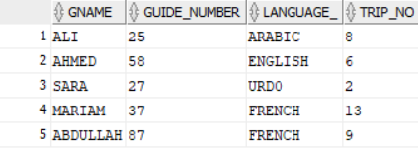
Tour_Trip Tour_guide

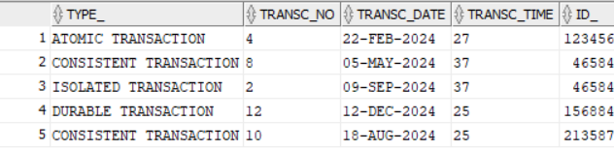
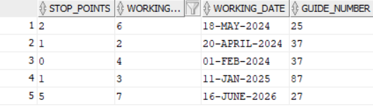
Schedule Transaction

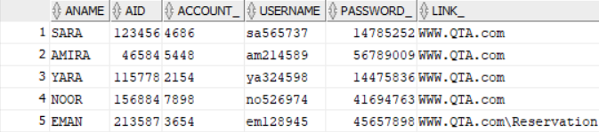
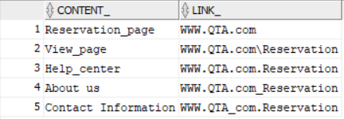
Agent QTA_Website

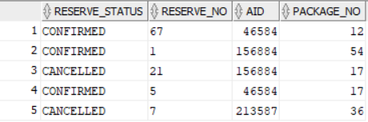
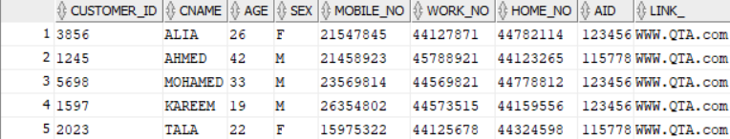
Customer Reservation

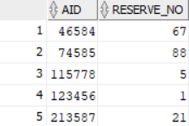
Tour_package Make
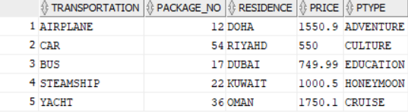

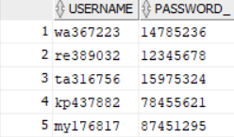
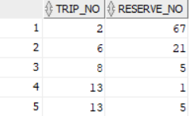
Done_T_R login_agent

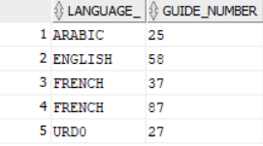
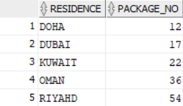
Tour_Package_Residence Tour_guide_lang

Here are the codes for tables from SQL:
create table Tour_Trip (Start_time varchar(20),Duration varchar(12),Destination varchar(12),Price varchar(19),Trip_date varchar(20) ,Trip_no varchar(2) PRIMARY KEY,Location_ varchar(20),Site_ varchar(15), Landmarks varchar(20) ,Package_no number(12),constraint tour_package_fk foreign key (Package_no) references Tour_package (Package_no) on delete cascade, constraint check_site check(Site_='Pearl' or Site_='Simaisma' or Site_='Qatar museum' or Site_='Banana Island'));
insert into Tour_Trip values (20 , 12 , 'DOHA' , 34.8 , '09-JAN-2024' , 2 , 'CENTRAL' , 'Pearl' , 'MOSQUE',12);
insert into Tour_Trip values (30 , 14 , 'LONDON' , 90.5 , '01-JAN-2027' , 6 , 'FAMOUS CLOCK' , 'Qatar museum' , 'BIG BEN',54);
insert into Tour_Trip values (40 , 16 , 'LONDON' , 31.2 , '02-FEBN-2024' , 8 , 'MOUNTAIN' ,'Simaisma' ,'JABAL ALSOODAH',54);
insert into Tour_Trip values (50 , 18 , 'DUBAI' , 74.8 , '19-MAR-2024' , 9 , 'FOUNTAIN' , 'Banana Island' ,'BURJ KHALIFA',17);
insert into Tour_Trip values (60 , 20 , 'DOHA' , 43.34 , '24-MAY-2025' , 13 , 'BEACH' ,'Pearl' ,'MARINA',12);
select * from Tour_Trip;
--drop table Tour_Trip;
create table Tour_guide (GName varchar2(20) , Guide_Number varchar(2) primary key , Language_ varchar(12) , trip_no varchar(2),constraint tour_trip_fk foreign key (trip_no) references Tour_trip (Trip_no) on delete cascade, constraint guide_lang_ck check(Language_='ARABIC'or Language_='ENGLISH'or Language_='URD0'or Language_='FRENCH'));
insert into Tour_guide values ('ALI' , 25 , 'ARABIC' ,8 );
insert into Tour_guide values ('AHMED' , 58 , 'ENGLISH' , 6);
insert into Tour_guide values ('SARA' , 27 , 'URD0' , 2);
insert into Tour_guide values ('MARIAM' , 37 , 'FRENCH' , 13);
insert into Tour_guide values ('ABDULLAH' , 87 , 'FRENCH' , 9);
select * from Tour_guide;
--drop table Tour_guide;

create table Schedule (Stop_points varchar(20) , Working_Time varchar(10), Working_Date varchar(20) , Guide_Number varchar(2) , constraint sch_tripno_fk foreign key (Guide_Number) references Tour_guide (Guide_Number) on delete cascade ,primary key(Working_Date,Guide_Number));
insert into Schedule values (2 , 6 , '18-MAY-2024',25);
insert into Schedule values (1 , 2 , '20-APRIL-2024',37);
insert into Schedule values (0 , 4 , '01-FEB-2024',37);
insert into Schedule values (1 , 3 , '11-JAN-2025',87);
insert into Schedule values (5 , 7 , '16-JUNE-2026',27);
select * from Schedule;
--drop table Schedule;

create table Transaction (Type_ varchar(35) , Transc_no varchar(2) primary key, Transc_date varchar(12) , Transc_Time varchar2(19) , Id_ number(9) , constraint trans_agentid_fk foreign key (Id_) references Agent1(AId)on delete cascade);
insert into Transaction values ('ATOMIC TRANSACTION' , 4 , '22-FEB-2024' , 27 , 123456);
insert into Transaction values ('CONSISTENT TRANSACTION' , 8 , '05-MAY-2024' , 37 , 46584 );
insert into Transaction values ('ISOLATED TRANSACTION' , 2 , '09-SEP-2024' , 37 , 46584);
insert into Transaction values ('DURABLE TRANSACTION' , 12 , '12-DEC-2024' , 25 , 156884);
insert into Transaction values ('CONSISTENT TRANSACTION' , 10 , '18-AUG-2024' , 25 , 213587 );
select * from Transaction;
--drop table Transaction;

create table Agent1 (AName varchar2(14) , AId number(9) primary key, Account_ varchar(10) unique, Username varchar2(13) unique , Password_ number(8) , Link_ varchar(30) , constraint agent_link_fk foreign key (Link_) references QTA_Website (Link_) on delete cascade);
insert into Agent1 values ('SARA' , 123456 , 4686 , 'sa565737' , 14785252 , 'WWW.QTA.com');
insert into Agent1 values ('AMIRA' , 46584 , 5448 , 'am214589' , 56789009, 'WWW.QTA.com');
insert into Agent1 values ('YARA' , 115778 , 2154 , 'ya324598' , 14475836, 'WWW.QTA.com');
insert into Agent1 values ('NOOR' , 156884 , 7898 , 'no526974' , 41694763, 'WWW.QTA.com');
insert into Agent1 values ('EMAN' , 213587 , 3654 , 'em128945' , 45657898, 'WWW.QTA.com\Reservation');
select * from Agent1;
--drop table Agent1;
create table QTA_Website (Content_ varchar(20) , Link_ varchar(30) primary key );
insert into QTA_Website values ('Reservation_page' , 'WWW.QTA.com');
insert into QTA_Website values ('View_page' , 'WWW.QTA.com\Reservation');
insert into QTA_Website values ('Help_center' , 'WWW.QTA.com.Reservation');
insert into QTA_Website values ('About us' , 'WWW.QTA.com_Reservation');
insert into QTA_Website values ('Contact Information' , 'WWW.QTA_com.Reservation');
select * from QTA_Website;
--drop table QTA_Website;
create table Reservation (Reserve_Status varchar(20) , Reserve_no varchar(10) primary key , AId number(9) ,Package_no number(12) , constraint res_Packageno_fk foreign key (Package_no)references Tour_package(Package_no) on delete cascade,constraint agent_id_fk foreign key (AId) references Agent1(AId) on delete cascade);
alter table Reservation add constraint check_status check(Reserve_Status='CONFIRMED' or Reserve_Status='CANCELLED');
insert into Reservation values ('CONFIRMED' , 67 , 46584,12 );
insert into Reservation values ('CONFIRMED' , 1 , 156884,54);
insert into Reservation values ('CANCELLED' , 21 , 156884,17);
insert into Reservation values ('CONFIRMED' , 5 , 46584,17);
insert into Reservation values ('CANCELLED' , 7 , 213587,36);
select * from Reservation;
--drop table Reservation;

create table Tour_package(Transportation varchar2(20) , Package_no number(12) primary key, Residence varchar2(13) , Price varchar(6) , PType varchar(12));
insert into Tour_package values ('AIRPLANE' , 12 , 'DOHA' , 1550.9 , 'ADVENTURE');
insert into Tour_package values ('CAR' , 54 , 'RIYAHD' , 550.0 , 'CULTURE');
insert into Tour_package values ('BUS' , 17 , 'DUBAI' , 749.99 , 'EDUCATION');
insert into Tour_package values ('STEAMSHIP' , 22 , 'KUWAIT' , 1000.5 , 'HONEYMOON');
insert into Tour_package values ('YACHT' , 36 , 'OMAN' , 1750.1 , 'CRUISE');
select * from Tour_package;
--drop table Tour_package;
create table Make(AId number(20) , Reserve_no number(12), primary key(AId,Reserve_no));
insert into Make values (123456 , 1);
insert into Make values (46584 , 67);
insert into Make values (213587 , 21);
insert into Make values (115778 , 5);
insert into Make values (74585 , 88);
select * from Make;
--drop table Make;
create table Done_T_R(Trip_no number(20) , Reserve_no number(12), primary key(Trip_no,Reserve_no));
insert into Done_T_R values (2 , 67);
insert into Done_T_R values (6 , 21);
insert into Done_T_R values (8 , 5);
insert into Done_T_R values (13 , 1);
insert into Done_T_R values (13 , 5);
select * from Done_T_R;
--drop table Done_T_R;

create table login_agent(username varchar2(20) primary key, password_ varchar(9) );
insert into login_agent values ('wa367223' , 14785236);
insert into login_agent values ('re389032' , 12345678);
insert into login_agent values ('ta316756' , 15975324);
insert into login_agent values ('kp437882' , 78455621);
insert into login_agent values ('my176817' , 87451295);
select * from login_agent;
--drop table login_agent;
create table Tour_Package_Residence(Residence varchar2(20),Package_no number(12) , constraint tourpack_Packageno_fk foreign key (Package_no)references Tour_package(Package_no) on delete cascade ,primary key(Residence,Package_no));
insert into Tour_Package_Residence values('DOHA' , 12);
insert into Tour_Package_Residence values('RIYAHD' , 54);
insert into Tour_Package_Residence values('DUBAI' , 17);
insert into Tour_Package_Residence values('KUWAIT' , 22);
insert into Tour_Package_Residence values('OMAN' , 36);
select * from Tour_Package_Residence;
--drop table Tour_Package_Residence;
create table Tour_guide_lang( Language_ varchar(12) ,Guide_Number varchar2(2) , constraint Tour_guide2_lang_num_fk foreign key (Guide_Number)references Tour_guide(Guide_Number) on delete cascade , constraint guide2_lang_ck check(Language_='ARABIC'or Language_='ENGLISH'or Language_='URD0'or Language_='FRENCH'),
primary key(Language_,Guide_Number));
insert into Tour_guide_lang values('ARABIC' , 25);
insert into Tour_guide_lang values('ENGLISH' , 58);
insert into Tour_guide_lang values('URD0' , 27);
insert into Tour_guide_lang values('FRENCH' , 37);
insert into Tour_guide_lang values('FRENCH' , 87);
select * from Tour_guide_lang;
--drop table Tour_guide_lang;

create table cust2 (Customer_ID varchar(9) primary key , CName varchar(25) , Age varchar(3) , Sex varchar(2) , Mobile_no varchar(8) unique , Work_no varchar(8) unique, Home_no varchar(8) unique, AId number(9) , Link_ varchar(30),constraint cust_sex_ch check (Sex='F' or Sex='M') , constraint cust2_link_fk foreign key (Link_) references QTA_Website(Link_) on delete cascade ,constraint cust2_sex_ch check (Sex='F' or Sex='M') , constraint cust2_agentid_fk foreign key (AId) references Agent1(AId) on delete cascade);
insert into cust2 values (3856 , 'ALIA' , 26 , 'F' , 21547845 , 44127871 , 44782114 , 123456,'WWW.QTA.com');
insert into cust2 values (1245 , 'AHMED' , 42 , 'M' , 21458923 , 45788921 , 44123265 ,115778 ,'WWW.QTA.com');
insert into cust2 values (5698 , 'MOHAMED' , 33 , 'M' , 23569814 , 44569821 , 44778812 , 123456,'WWW.QTA.com');
insert into cust2 values (1597 , 'KAREEM' , 19 , 'M' , 26354802 , 44573515 , 44159556 , 123456,'WWW.QTA.com');
insert into cust2 values (2023 , 'TALA' , 22 , 'F' , 15975322 , 44125678 , 44324598 ,115778 ,'WWW.QTA.com');
select * from cust2;
--drop table cust2;
-- Q7
set serveroutput on;
CREATE OR REPLACE TRIGGER cust2changestrigger
AFTER INSERT OR DELETE OR UPDATE ON cust2
FOR EACH ROW
BEGIN
INSERT INTO Transaction (Type_, Transc_no, Transc_date, Transc_Time,cust2.AId)
VALUES ('CUSTOMER TRANSACTION', 1, '01-01-2025', TO_CHAR(SYSDATE, 'HH24:MI:SS'), 2);
END;

First, we make a connection in java to connect it with the SQL to be able to solve the questions.
- Login Screen with a Username and Password for Agent only. Retrieve Username and
Password from login table. (Use your own Username and Password to Login and connect to the Oracle Database Server).
To retrieve the username and password we create a statement then we select the username and password to connect it with SQL after that we go through it to print the whole information about the agents’ username and passwords.

- Add a new Customer and Make Reservation.
In this question we made two methods one for adding a new customer information and the other for making a reservation
For adding customer information we prepared a statement to insert the new information after we insert it we will set it in the statement depend on the type (int , string ,..).
The second method was for making a reservation same as adding customer we will make it to the reservation but it will depend on the information that needed for the reservation.
Both of the methods we use scanner to enter the new information.
For sure, all of this insertion the agent will make it because he/she is the only person that can enter and updating the information as required by the client.

- Remove a Customer and his/her Reservation.
We had created a method to delete the customer information and reservation
First, we create a string to delete customer and we wrote query to delete all the information required.
Second, we also made a string to update the reservation, in this one we wrote it as a subquery to automatically update the reservation based on removing the customer information.
Last thing and is the last string to delete everything from the ‘make’ table that will remove a customer and reservation based on the Aid and Reserve_no.
After that, we prepared a statement to put the three strings on it and set it based on the type then execute.
Lastly, in the main method we use a scanner to enter the id then used the method that we have done.

- Update Customer’s Information.
We used a scanner to the agent can enter the updated customer information needed then we write the update query after that we prepared a statement to use this query and connect it to the SQL later we set all the information about the updated depends on the type of each attribute.

- Add and Update the information of tour trip.
First, we had created a method for adding information about the tour trip using prepared statement to insert to the table after that in the main method we use the scanner so the agent can put the information that the customer need for the trip.
Also we create a method for update any information about the trip, same as the first we use prepare statement but here we need to update the information and we will check if the row updated or not using if statement and printing a message, also in the main method we use the scanner so the agent can enter the new information.

- Search by Customer ID to retrieve information about his/her Reservations.
First, we made a scanner to enter the customer id to retrieve all the reservation information for this customer.
Second, we wrote two queries one to select everything from ‘customer’ table based on the id he/she entered and the second one to select everything from ‘customer’ and ‘reservation’ tables after that execute this queries.
Third, we will use the while statement for both customer and reservation to go iteration all the information offered to this customer and reservation but this time we will use the ‘get’.
Lastly, to retrieve all the information we will use ‘System.out.println’.

- The system must fire a SQL trigger whenever adding, removing, and updating a customer or reservation. The trigger must store the following information (Transaction Date/Time, User Name, Agent ID)
We created a trigger for each inserting, deleting and updating and based on each of them we inserted, updated and deleted.
-- Q7
set serveroutput on;
CREATE OR REPLACE TRIGGER cust2changestrigger
AFTER INSERT OR DELETE OR UPDATE ON cust2
FOR EACH ROW
BEGIN
INSERT INTO Transaction (Type_, Transc_no, Transc_date, Transc_Time,cust2.AId)
VALUES ('CUSTOMER TRANSACTION', 1, '01-01-2025', TO_CHAR(SYSDATE, 'HH24:MI:SS'), 2);
END;

- The System must provide the following reports: (All Reports are based on Views)
8-1- Reservations (All Reservation Information and the Status of the Reservations).
8-2- Trips (All Tour Trips and their Guides).

We created two views:
*One to select all the data in the reservation table with the status:
*code from SQL:
--8-1
create view all_reservation as select * from Reservation;
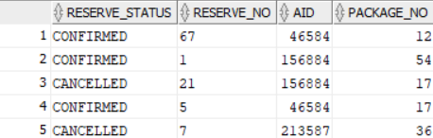
select * from all_reservation;

*Second to select the entire attribute in the ‘tour trip’ table and in the ‘tour guide’ table:
--8-2
create view all_trips_guides as
select tt.Trip_no, tt.Start_time, tt.Duration, tt.Destination, tt.Price, tt.Trip_date, tt.Location_, tt.Site_, tt.Landmarks, tt.Package_no, tg.GName AS Guide_Name, tg.Language_
from Tour_Trip tt
join Tour_guide tg on tt.Trip_no = tg.trip_no;
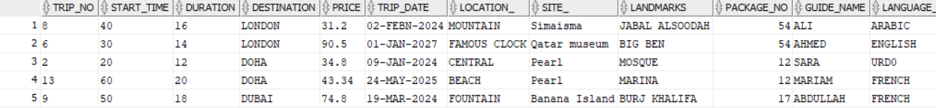
select * from all_trips_guides;
Create the Screens using Java Swing Windows Builder or Java FX.
We will design a swing to the agent so she/he can enter her/his username and password correctly, if they didn’t enter one of them or both correctly it will appear a message, if they enter both correctly and click ‘continue’ it will appear a window that have many choices for customer, tour trip, report and exit and each of them will have something to do.

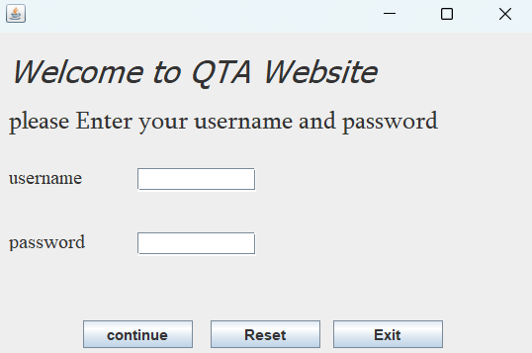
First, we have the login window:

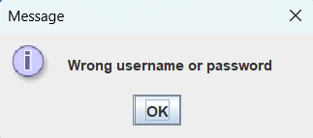
If he/she enter, one of them or both wrong message will appear:

If he/she enter all the data correctly and press ‘continue’, it will appear this menu:
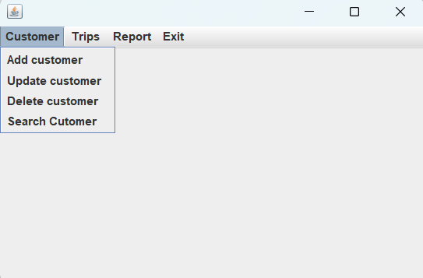
There are several options for each of the available options, depending on the customer desire. The agent changes the data:

Now if we choose from the options to add a customer to the table it will appear this window then it will make a reservation:
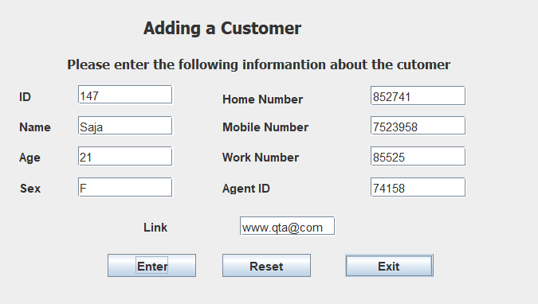

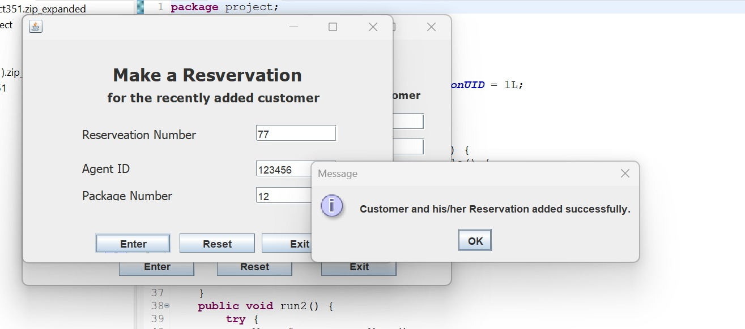

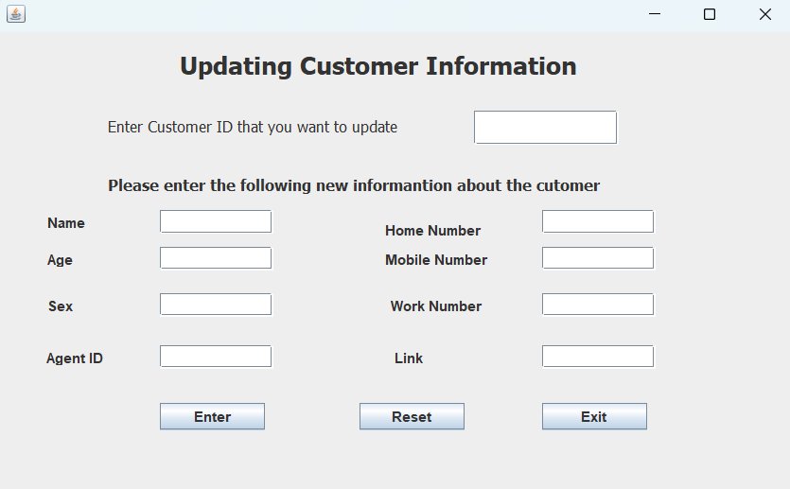
Update Customer:

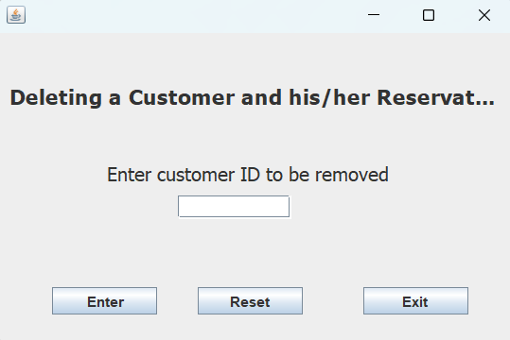
Delete Customer:
Search for a Customer:
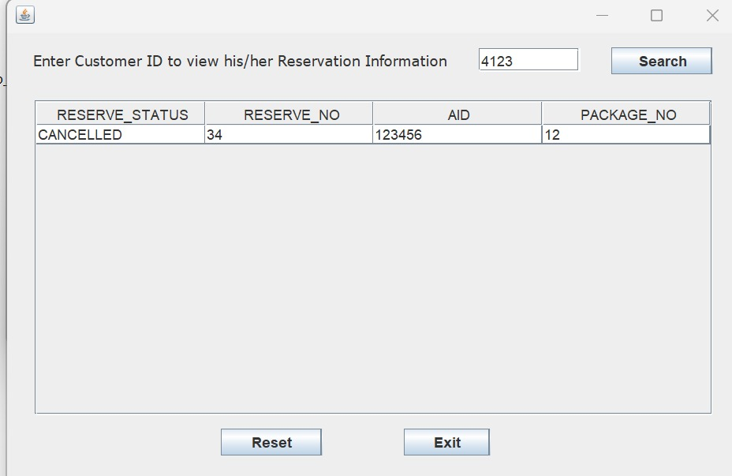
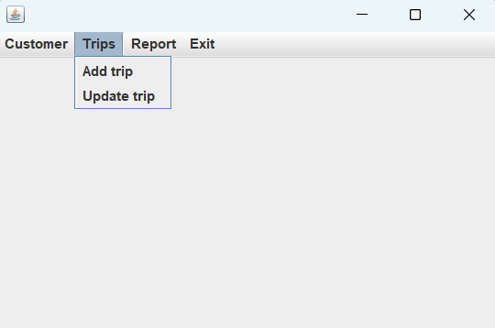
In addition, there are options for the Trip:

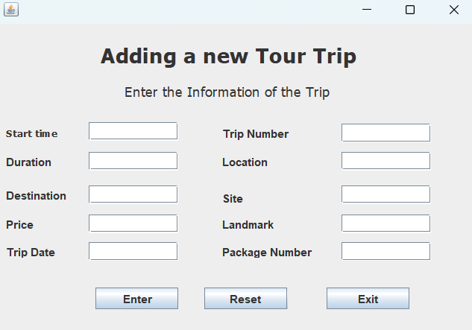
Add Trip:

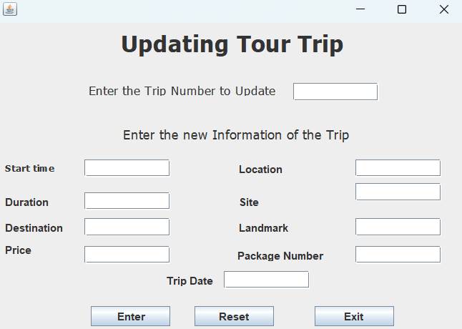
Update Trip:

The Java Classes AS A ZIP FILE:

